Hardware & Structure of Computer

What is Hardware?
Hardware refers to all the physical components of a computer system that can be seen and touched. These components work together to perform computing tasks.
Examples: CPU, Monitor, Keyboard, Mouse, RAM, Hard Disk, Motherboard

Block Diagram of Computer
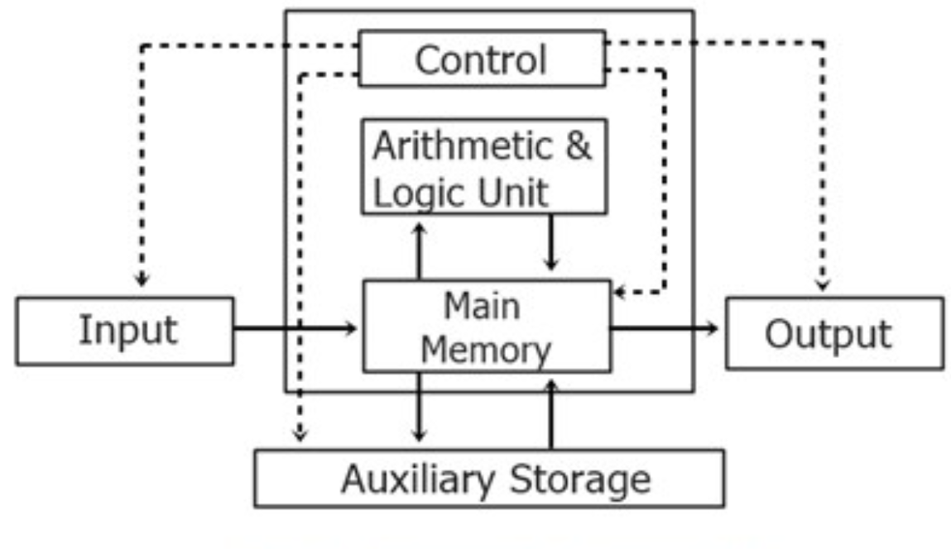

Explanation:
- Input Unit

  - It is responsible for taking input (data/instructions) from the user
  - Converts input into a form that the computer can understand (binary form)
  - Sends data to the CPU for processing
Examples: Keyboard, Mouse, Scanner, Microphone

CPU (Central Processing Unit)

  - Known as the brain of the computer
  - Performs all calculations and logical operations
  - Controls and manages all parts of the computer

Main Parts of CPU:
  - ALU (Arithmetic Logic Unit):
Performs arithmetic operations (addition, subtraction) and logical operations (AND, OR, NOT)

CU (Control Unit):
Controls the execution of instructions and directs data flow between components

Registers:
Small, fast storage inside CPU used for temporary data

Memory Unit

Primary Memory:
  - Directly connected to CPU
  - Fast but temporary Examples:
  - RAM (Random Access Memory): Stores data currently in use
  - Cache Memory: Very fast memory used to speed up processing

Secondary Memory (Auxiliary):
  - Used for permanent storage
  - Slower than primary memory but stores large data Examples:
  - HDD, SSD, Pen Drive

Output Unit

  - Displays the processed result to the user
  - Converts machine language output into human-readable form
Examples: Monitor, Printer, Speakers

Software

What Problems Software Solves
Software acts as a bridge between the user and hardware. Without software, hardware cannot perform any meaningful task.

Problems solved by software:
- Provides instructions to hardware
- Makes complex tasks easy (e.g., calculations, editing)
- Automates repetitive work
- Improves productivity and efficiency
- Enables communication and data processing

First Software: Operating System (OS)

- The Operating System is the first software that loads when a computer starts (booting process)
- It acts as an interface between user and hardware
- It manages all hardware resources and software applications

Main Functions of OS:
- Process management
- Memory management
- File system management
- Device management
- Security and user control

Comparison of Operating Systems

Feature | Windows | Linux | macOS
Developer | Microsoft | Open-source community | Apple
Ease of Use | Very easy | Moderate | Easy
Cost | Paid | Free | Paid
Security | Medium | High | High
Customization | Limited | Very High | Limited
Usage | General users, gaming | Developers, servers | Apple ecosystem

Types of Computers

Desktop Computer

  - Fixed at one place
  - Separate components (monitor, CPU, keyboard, mouse)
  - Used in offices, schools, and labs

Laptop

  - Portable and compact
  - All components integrated into one device
  - Battery-powered and easy to carry

Mobile / Tablet

  - Small and lightweight
  - Touch-based interface
  - Used for communication, entertainment, and daily tasks

Branded vs. Assembled Computers

Branded Computer

  - Manufactured by companies like HP, Dell, Lenovo
  - Comes with pre-defined configuration

Advantages:
  - Reliable and stable performance
  - Good customer support and warranty
  - Easy to use

Disadvantages:
  - Expensive
  - Limited customization

Assembled Computer

  - Custom-built using selected components

Advantages:
  - Cost-effective
  - Customizable as per needs
  - Better performance for same budget

Disadvantages:
  - Requires technical knowledge
  - No single warranty (separate for parts)

Conclusion

  - Branded computers are suitable for general users
  - Assembled computers are better for advanced users, gamers, and institutions

Basic Components of a Computer

CPU

  - Brain of computer
  - Executes instructions and controls operations

RAM (Random Access Memory)

  - Temporary working memory
  - Stores active data and programs

Why Random Access?
  - Any data can be accessed directly without sequence

DDR4 vs DDR5

Feature | DDR4 | DDR5
Speed | Moderate | Very High
Power | Higher | Lower
Usage | Normal tasks | AI, gaming, heavy tasks

Mobile vs Laptop RAM

  - Mobile RAM is fixed and not upgradeable
  - Laptop RAM is upgradeable and more powerful
  - Same size RAM does not mean same performance

Storage Devices
HDD (Hard Disk Drive)

  - Mechanical storage
  - Slower but cheaper

SSD (Solid State Drive)

  - Flash-based storage
  - Very fast and reliable

Important Insight:
Switching from HDD to SSD greatly improves system speed

How a Computer Works (Simple Flow)

  - Step 1: Input is given by user
  - Step 2: CPU processes the data
  - Step 3: Output is displayed

Example:
Typing a search → CPU processes → Results shown on screen

System Configuration & Performance

System Configuration
It refers to the combination of hardware and software details of a system:
  - Processor (CPU)
  - RAM
  - Storage (HDD/SSD)
  - Operating System

How to Check (Windows):

  - Press Windows + R → type
dxdiag
  - Right-click This PC → Properties

Ways to Increase Performance

  - Upgrade RAM for better multitasking
  - Replace HDD with SSD for speed
  - Uninstall unused applications
  - Clean storage regularly
  - Restart system to refresh memory

Connection with AI

  - AI applications require high computing power
  - More RAM allows smooth multitasking
  - SSD ensures faster data access
  - Low-end systems may lag while running AI tools

Conclusion:
For better AI performance, a system with high RAM and SSD is recommended

Assignment 1: “Device Detective Challenge”

Part 1: Data Collection

Device 1 (My Device)

  - Device Type:
  - RAM:
  - Storage Type:
  - Processor:
  - Age of Device:
  - Speed Performance:

Device 2 (Friend’s Device)

  - Device Type:
  - RAM:
  - Storage Type:
  - Processor:
  - Age of Device:
  - Speed Performance:

Device 3 (Family Member’s Device)

  - Device Type:
  - RAM:
  - Storage Type:
  - Processor:
  - Age of Device:
  - Speed Performance:

Part 2: Analysis Questions

Which device is fastest and WHY?

Does RAM or SSD affect speed more? Explain with proof.

Why mobile phones feel fast even with lower RAM sometimes?

Which device would you upgrade and what will you change?

Part 3: Knowledge Sharing Activity Discussion with 2 People (Friends/Classmates) Topics Explained:
  - How to check system configuration
  - Difference between HDD and SSD

Reflection:
- What questions did they ask you?

What confusion did they have?

- Were you able to explain clearly? (Yes/No + Why)

What new thing did you realize while explaining?

Assignment 2: “Speed Booster Expert”

Part 1: System Analysis

My System Configuration:

- RAM:
- Processor:
- Storage:

Part 2: Identify Problems (Minimum 3 reasons)

Part 3: Suggested Improvements (3 Points)

Part 4: Concept Understanding

What happens if RAM is increased?

What happens if HDD → SSD?

Can software also affect speed? How?

Part 5: Challenge Twist (Comparison)

Ask a Friend/Family Member: How to make computer faster?

Their Suggestions:

My Solution vs Friend’s Solution

My Solution | Friend’s Solution

Final Learning:

